**12215949 SUDHARSAN B K22GM25**

Output

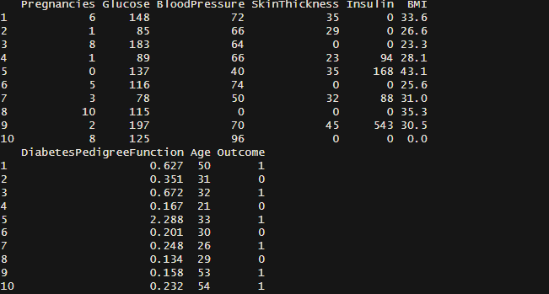

Finding the Mean

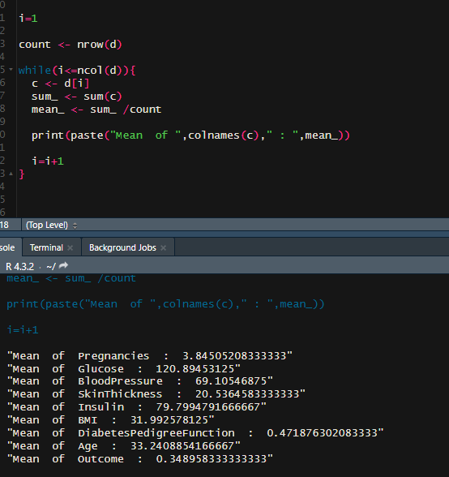

Finding the Maximum value

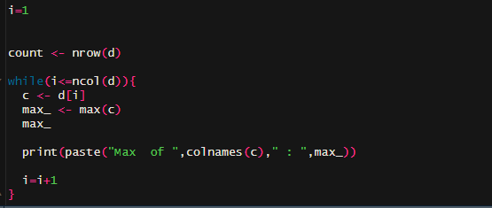

Finding the minimum value

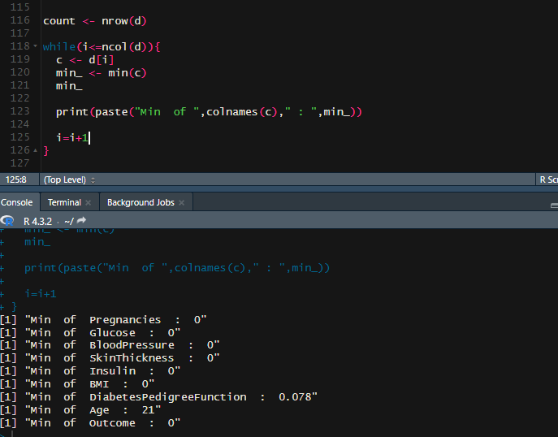

Finding the number of columns and rows present in the data frame



